Alternative Solutions and Designs

Each member of the team came up with their own designs for the application. The overall design was created using different ideas and functions from each individual design.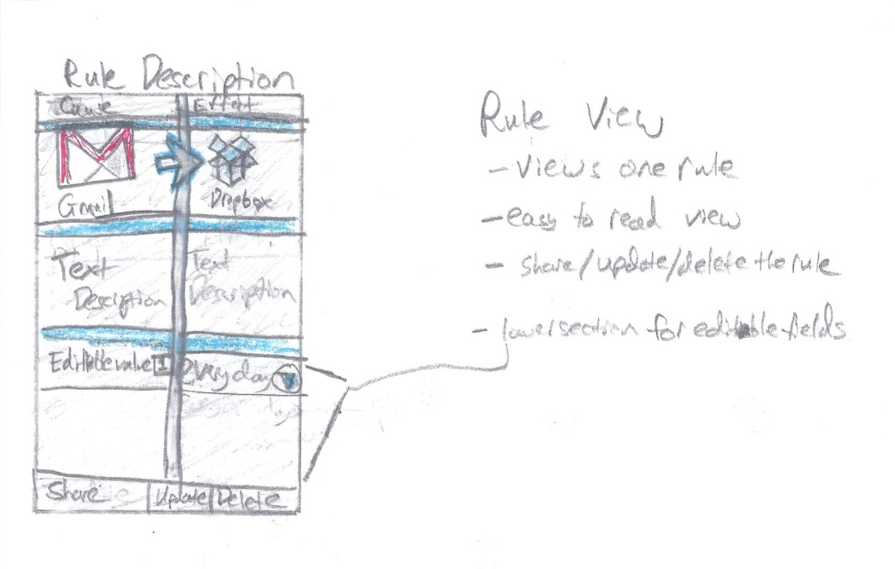

* Here, the user will follow the rule description page as they create the rule. They click on the cause size to choose a cause, and the effect page to choose an effect. As the user adds causes and effects, they will return to this page to see how their rule looks as they create it.

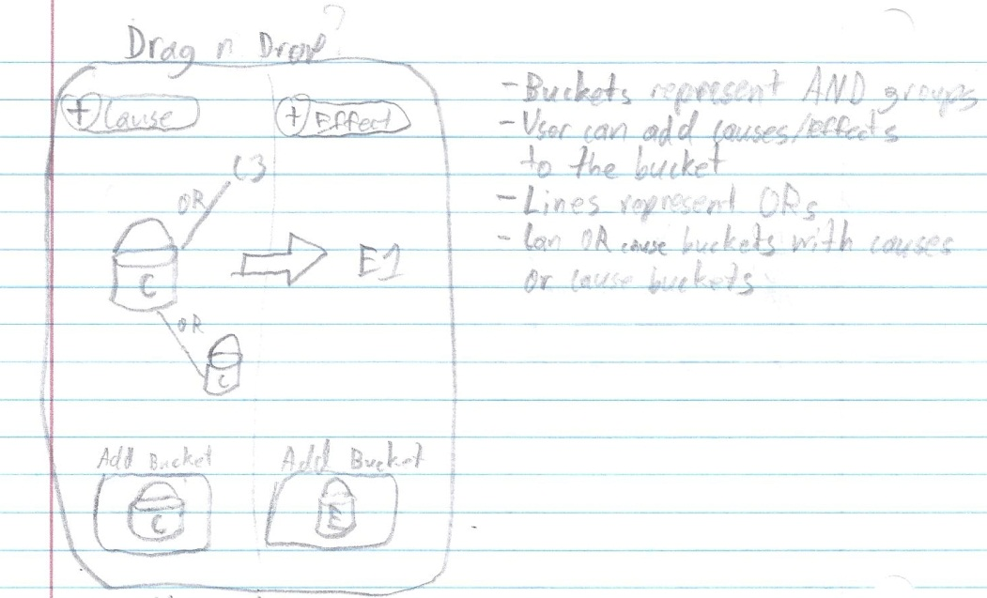

* Here is an idea for a drag and drop implementation of the rule creation page, in which users place selections in “buckets” to represent groups of causes or effects, and link them to other buckets or individual items by an OR line. This would create a more abstract view of how the user creates rules.

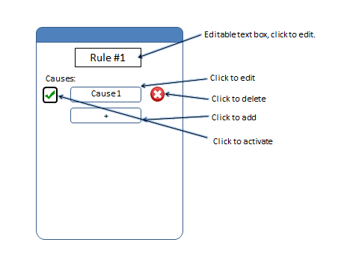

* Here is a rule creation page in which causes and effects are separated by different pages and takes a more list view approach.

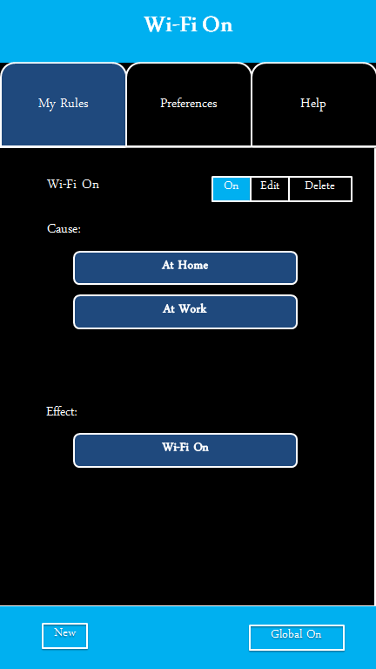

* Another rule view where causes and effects are listed sequentially in a list format.

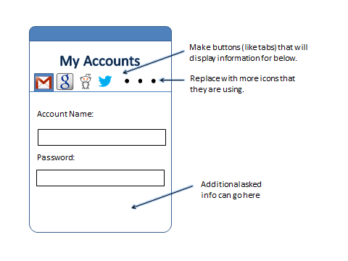

* This is an accounts page in which the user syncs their Google, Facebook, etc. accounts for use with rule creation. Another idea was moving the list of accounts to a separate page accessed from preferences, rather than a slide at the top.

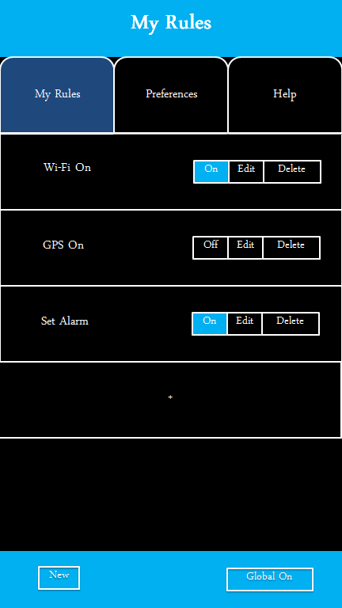

* This was an idea for viewing existing rules. It has options to turn each rule on or off, delete, and edit.

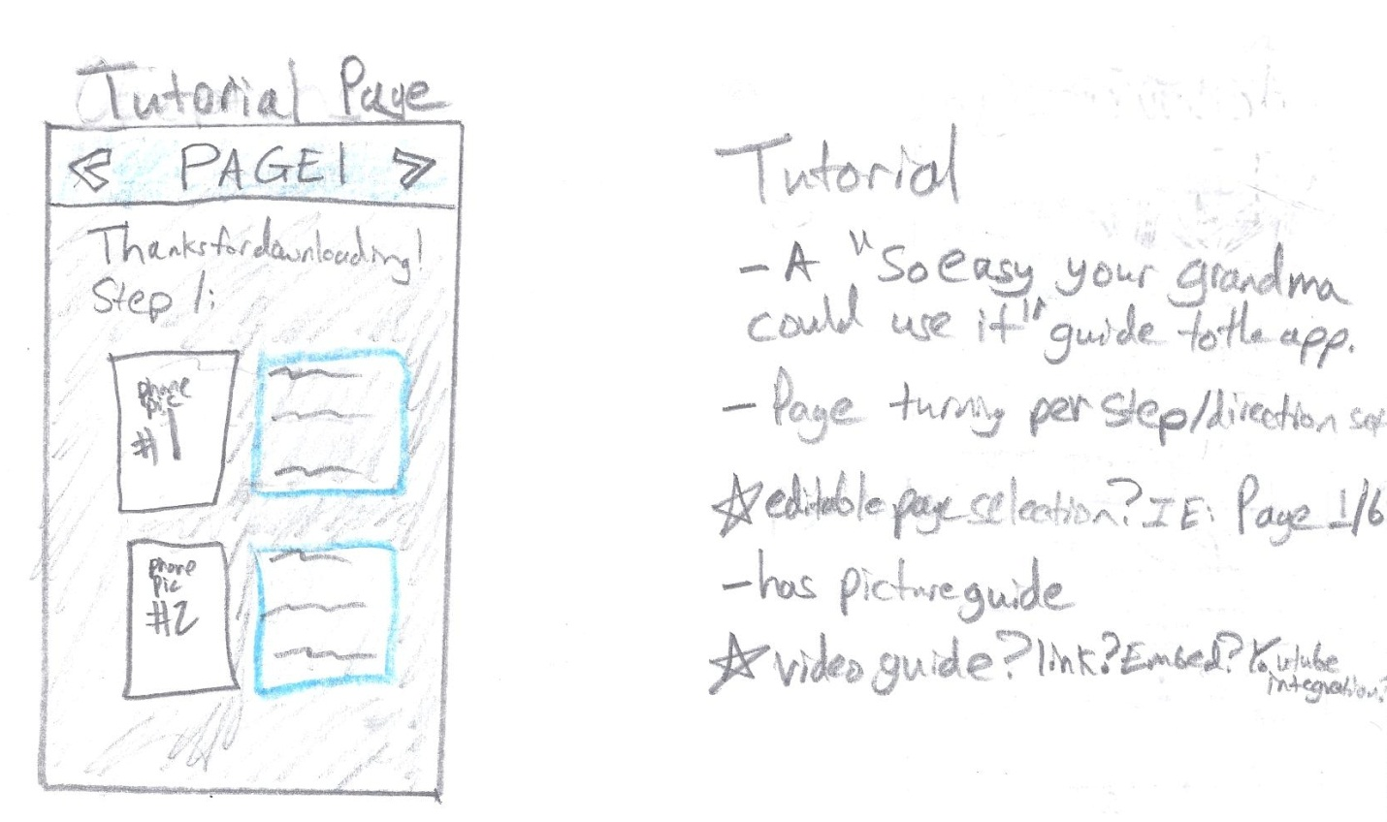

* One idea we had was for a tutorial page or overlay, where first time users can learn how to use the app.

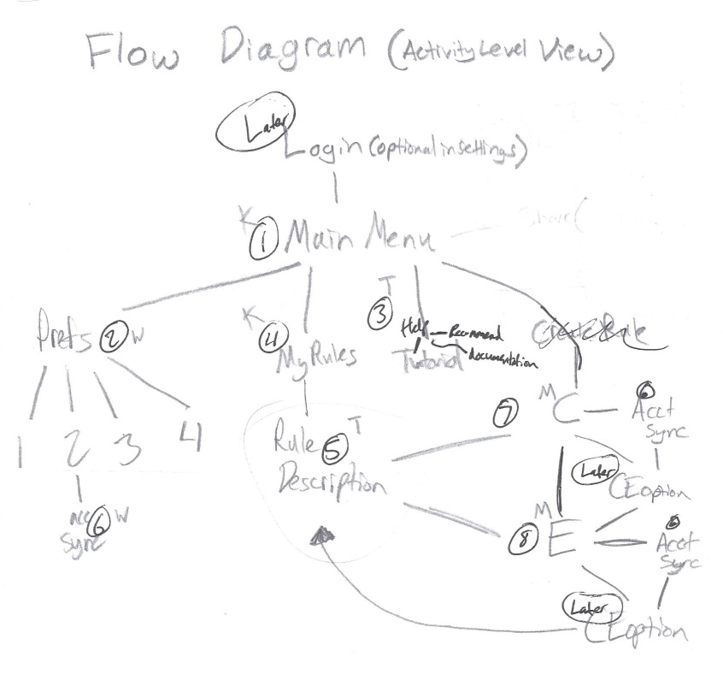

* This is the general flow diagram that is being used for the navigation and usage of the app.